

Instituto Tecnológico y de Estudios Superiores de Monterrey
Data Analytics and Artificial Intelligence Tools
Stage 4.3 Report
Correlation, Linear Regression and Time Series Analysis
Panem Demand Forecasting
Team 5
Jesús Emiliano Morales Villela — A00840087
Luis Diego Dominguez Larrieta — A01275640
David Alexander López Guzmán — A00835935
Jose Dolores Gomez Soto — A01712281
Ignacio Xavier Chávez Quiroz — A00574357

Index
1. Executive Summary
2. Business Context and Analytical Objective
3. Dataset Construction and Feature Preparation
4. Correlation Analysis
5. Selected Product: CONCHA VAINILLA
6. Linear Regression Models
7. Time Series Analysis and 6-Month Forecast
8. Model Validity, Limitations and Recommendations
9. Conclusion

1. Executive Summary
This Stage 4.3 analysis applies the CRISP-DM Modeling phase to Panem’s historical sales data, focusing on three connected tasks: correlation analysis, linear regression, and time-series forecasting. The purpose is to understand which variables are most related to sales quantity and how historical behavior can be used to anticipate future demand for a key product.
The notebook merged seven branch datasets into a single analytical table with 574,738 rows and 29 variables, covering the period from 2022-01-31 to 2026-02-12. The main target variable is quantity, interpreted as units sold. The analysis selected CONCHA VAINILLA as the focal product because it is the highest-volume item in the dataset, with 236,793 units sold and 8,130 rows available for modeling.
The central statistical finding is that recent sales history is the strongest predictor of current quantity. Rolling demand features show correlations with quantity between 0.54 and 0.71, while calendar, branch and weather variables show much weaker direct linear correlations. This does not mean that calendar and weather are irrelevant, but it suggests that their relationship with demand is less direct and may require interaction terms or non-linear models.
Two linear regression models were compared. Model A used only calendar, branch and weather variables and achieved MAE = 16.050, RMSE = 20.810 and R² = 0.1601. Model B added rolling demand features and improved performance to MAE = 11.862, RMSE = 16.424 and R² = 0.4768. This means Model B explains substantially more test variation and reduces average error, but it remains imperfect because demand is noisy, count-like, and affected by unobserved factors such as promotions, stockouts and branch operations.
Finally, the time-series analysis shows an upward monthly trend for CONCHA VAINILLA, with a trend slope of +93.50 units per month. Seasonality indicates a peak around month 5 and a trough around month 2. Holt-Winters and SARIMA were used for a six-month forecast, with Holt-Winters serving as the more stable primary model and SARIMA as a cross-check. The forecasts should be used as planning guidance with managerial review and safety buffers, not as automatic exact production quantities.

2. Business Context and Analytical Objective
Panem’s operational problem is a demand planning problem. The company needs to decide how many units of each product should be prepared and distributed before actual demand is fully known. In this context, overproduction creates waste and underproduction creates lost sales and lower customer satisfaction. Therefore, the analysis focuses on units sold rather than revenue because production decisions require physical quantities.
From a statistical and machine learning perspective, the task is a supervised regression problem with temporal dependence. The target is quantity and the explanatory variables include calendar features, branch identifiers, temperature/weather indicators, holiday flags and rolling historical demand features. The notebook specifically evaluates whether these variables help explain and predict sales quantity for the selected top product.

3. Dataset Construction and Feature Preparation
The source data is divided by branch. The notebook loaded seven branch datasets and then concatenated them into one merged DataFrame. The resulting analytical base has 574,738 rows and 29 columns, with observations from 2022-01-31 to 2026-02-12. This consolidated structure allows the model to evaluate demand behavior across all branches while still preserving branch-level information through the sucursal variable and its encoded form.
Branch dataset | Rows | Columns
punto_valle | 107,602 | 20
plaza_qin | 104,025 | 20
plaza_nativa | 53,502 | 20
hotel_kavia | 85,698 | 20
hospital_zambrano | 93,500 | 20
credi_club | 24,123 | 20
carreta | 106,288 | 20
Table 1. Branch-level dataset sizes loaded in the notebook.
Feature engineering expanded the raw sales records into a more suitable modeling table. The notebook created time variables such as week_of_year, day_of_week, year and quarter; categorical encodings such as sucursal_code and season_code; binary variables such as is_holiday and is_warm; and rolling historical demand variables such as qty_roll_1, qty_roll_3, qty_roll_7, qty_roll_15, qty_roll_30, qty_roll_60, qty_roll_90, qty_roll_180 and qty_roll_365.

4. Correlation Analysis
The correlation analysis used the numeric variables in the merged dataset. Conceptually, the Pearson correlation coefficient measures the direction and strength of a linear relationship between two numeric variables. Values near +1 indicate strong positive linear association, values near -1 indicate strong negative association, and values near 0 indicate weak linear association. Correlation is useful for preliminary feature selection, but it does not prove causality.
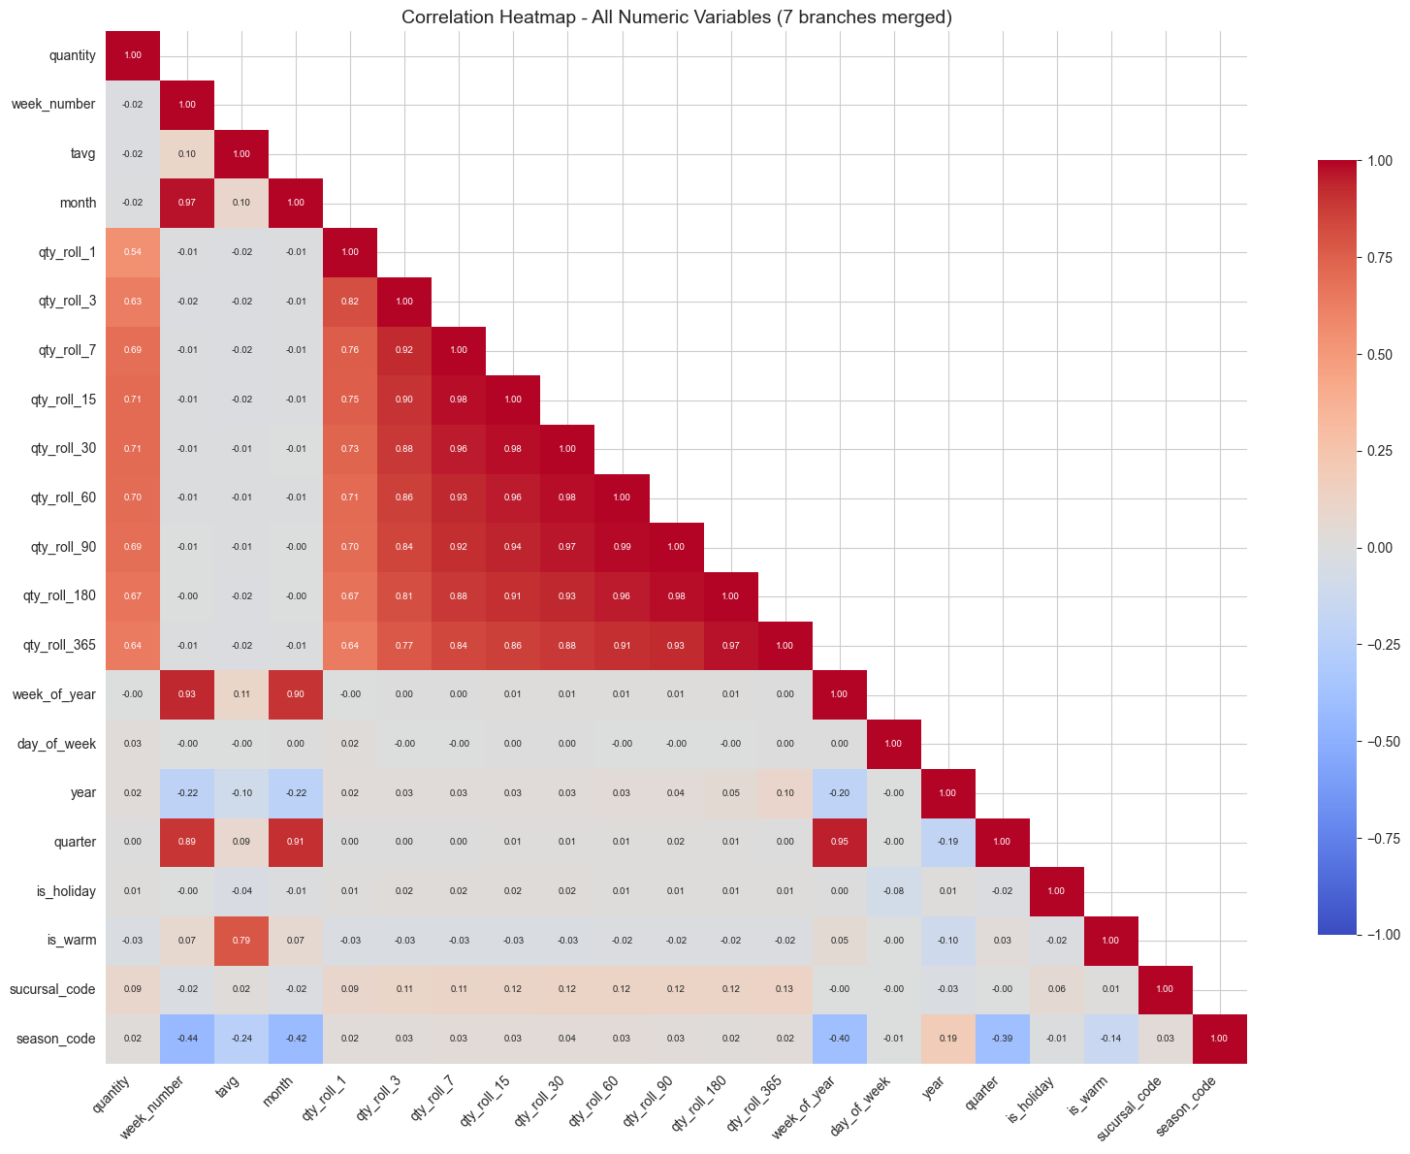
Figure 1. Correlation heatmap for all numeric variables in the seven-branch merged dataset.
Variable | Correlation with quantity | Interpretation
qty_roll_15 | 0.7109 | Strongest linear association with current sales quantity.
qty_roll_30 | 0.7067 | Recent monthly average demand is highly informative.
qty_roll_60 | 0.6972 | Medium-term demand history remains relevant.
qty_roll_7 | 0.6940 | Weekly demand pattern is important for bakery products.
qty_roll_90 | 0.6881 | Quarterly rolling behavior still provides signal.
qty_roll_1 | 0.5437 | Prior-day demand has moderate predictive value.
sucursal_code | 0.0869 | Branch code has weak direct linear association.
is_warm | 0.0263 | Warm weather alone has weak direct linear correlation.
day_of_week | 0.0257 | Day of week may matter non-linearly or through branch/product interactions.
tavg | 0.0184 | Average temperature alone is not strongly linearly related to quantity.
Table 2. Top visible correlations with quantity from the notebook output.
The heatmap clearly shows that the rolling quantity variables dominate the relationship with current sales. This is expected in demand forecasting: past demand usually captures product popularity, branch habits and weekly consumption patterns better than isolated calendar or weather variables. At the same time, many rolling variables are strongly correlated with one another, which creates multicollinearity in a simple linear regression model. For interpretability, this means their individual coefficients should not be overinterpreted as independent causal effects.
The heatmap also shows redundancy among calendar variables: month and week_number are highly related, as are quarter and week_of_year. This is normal because these variables represent the same time axis at different levels of aggregation. For future models, one-hot encoding, regularization or tree-based methods would handle these relationships more safely than a basic linear model with ordinal encodings.

5. Selected Product: CONCHA VAINILLA
The notebook selected the top-selling product across all branches as the modeling target. This choice is statistically reasonable because a high-volume item contains more historical signal and is operationally relevant for production planning. The selected item was CONCHA VAINILLA, with 236,793 units sold and 8,130 rows in the selected product dataset.
Rank | Item | Total quantity
1 | CONCHA VAINILLA | 236,793
2 | CONCHA CHOCOLATE | 103,110
3 | CHILAQUILES PANEM | 88,993
4 | CROISSANT ALMENDRAS | 56,566
5 | PAIN AU CHOCOLAT | 49,020
6 | MUFFIN BLUEBERRY | 44,485
7 | GALLETA DE AVENA | 41,473
8 | ROL DE CANELA | 41,166
9 | ENCHILADAS SUIZAS | 40,260
10 | CROISSANT DE JAMÓN Y QUESO | 40,130
Table 3. Top ten items by total quantity in the merged dataset.
The gap between CONCHA VAINILLA and the second product is large: CONCHA VAINILLA sold more than twice as many units as CONCHA CHOCOLATE. For Panem, this means that improving the forecast for this product can have a high operational impact because even small percentage improvements may translate into many physical units.

6. Linear Regression Models
Two linear regression models were trained to predict sales quantity for CONCHA VAINILLA. The purpose was not only to produce a prediction, but also to compare how much explanatory value is gained when historical demand features are added to basic calendar, branch and weather variables.
Metric | Model A: calendar + branch + weather | Model B: Model A + rolling demand | Improvement from A to B
MAE | 16.050 | 11.862 | 26.1% lower
RMSE | 20.810 | 16.424 | 21.1% lower
R² | 0.1601 | 0.4768 | +0.3167 points
Table 4. Linear regression performance comparison on the test sample.
- Model A is weak but interpretable. Its R² of 0.1601 means that calendar, branch and weather variables alone explain only a limited part of daily demand variation.
- Model B is substantially better because rolling historical demand variables capture persistence and weekly purchasing behavior. It reduced MAE from 16.050 to 11.862 units.
- The improvement confirms that Panem demand is highly dependent on recent sales history. However, this also means the model is more appropriate for short-horizon prediction than long-range forecasting.
- Coefficients for sucursal_code and season_code should be interpreted carefully because these are numeric encodings of categories, not naturally continuous variables. A stricter regression design should use one-hot encoding or regularization.
The coefficient signs are directionally useful but not causal. In Model A, is_holiday had a positive coefficient (+4.1783), while is_warm had a negative coefficient (-5.1680). After adding rolling demand features in Model B, these effects became smaller, which suggests that part of what looked like a weather or holiday effect was already captured by recent demand behavior.
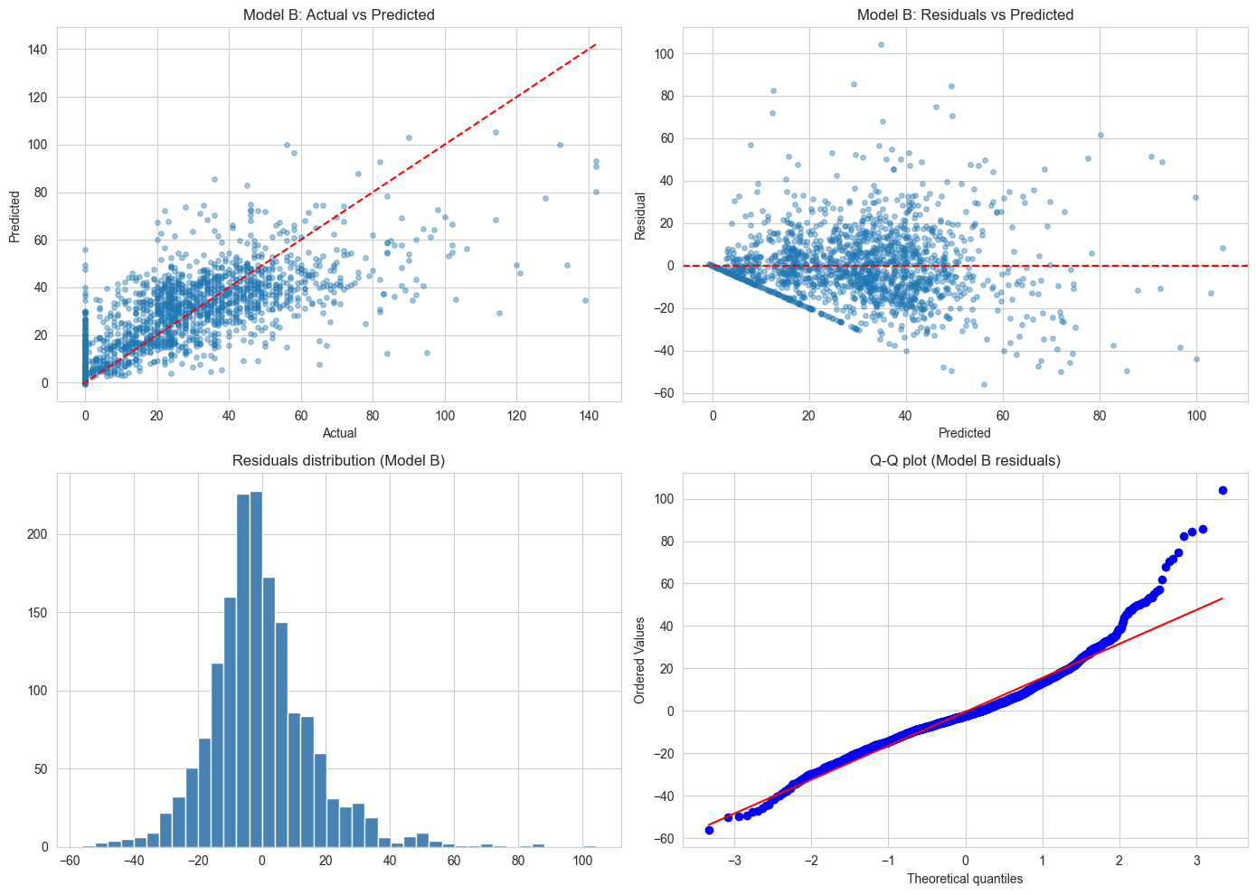
Figure 2. Model B diagnostic plots: actual vs. predicted, residuals, residual distribution and Q-Q plot.
The diagnostic plots show that Model B captures the general direction of demand but does not fully satisfy linear regression assumptions. The actual vs. predicted plot shows that high-demand days are often underpredicted. The residuals vs. predicted plot shows changing variance, while the histogram and Q-Q plot indicate heavy tails and non-normal residuals. This is expected because sales quantity is count-like, has spikes, and can include many low or zero values.

7. Time Series Analysis and 6-Month Forecast
For the time-series section, the selected product was aggregated across all branches by operating_date. The notebook created a daily series and then resampled it into monthly sales, which is a more stable granularity for a six-month forecast. The daily series contains 1,474 observations from 2022-01-31 to 2026-02-12, while the monthly series contains 50 observations from 2022-01-01 to 2026-02-01.
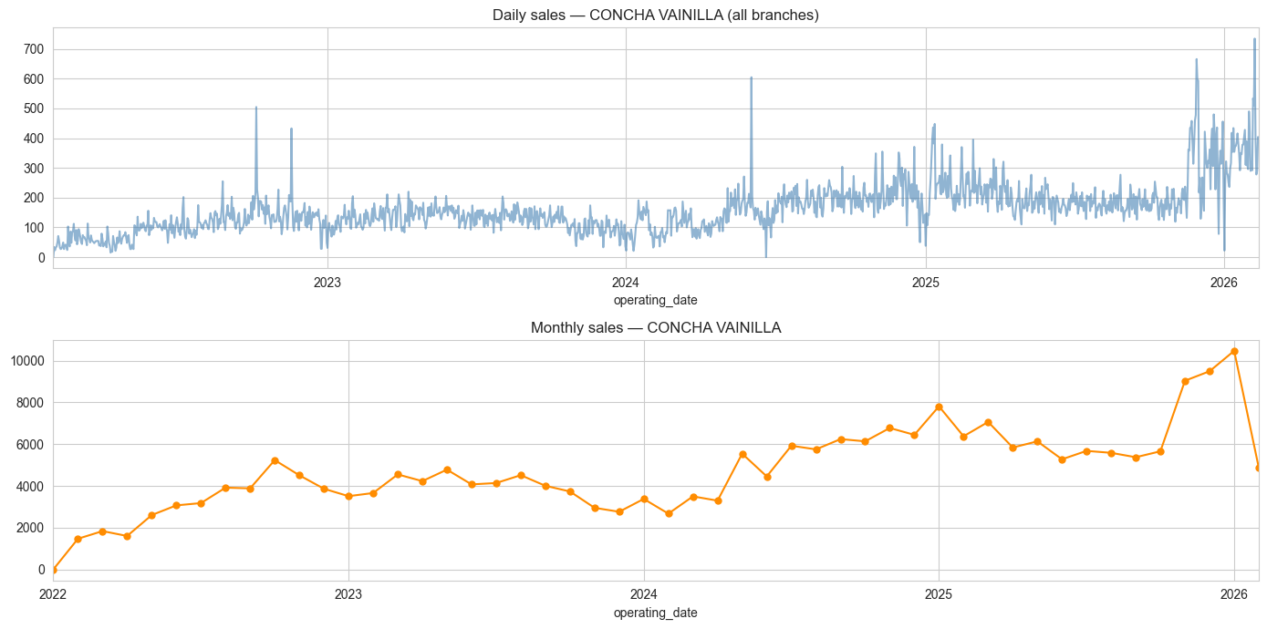
Figure 3. Daily and monthly sales series for CONCHA VAINILLA across all branches.
The daily series shows substantial volatility and several spikes, which is normal in food retail demand. The monthly series smooths that volatility and makes the broader direction easier to interpret. Visually, demand increases over the full observation window, with particularly high values near late 2025 and early 2026.
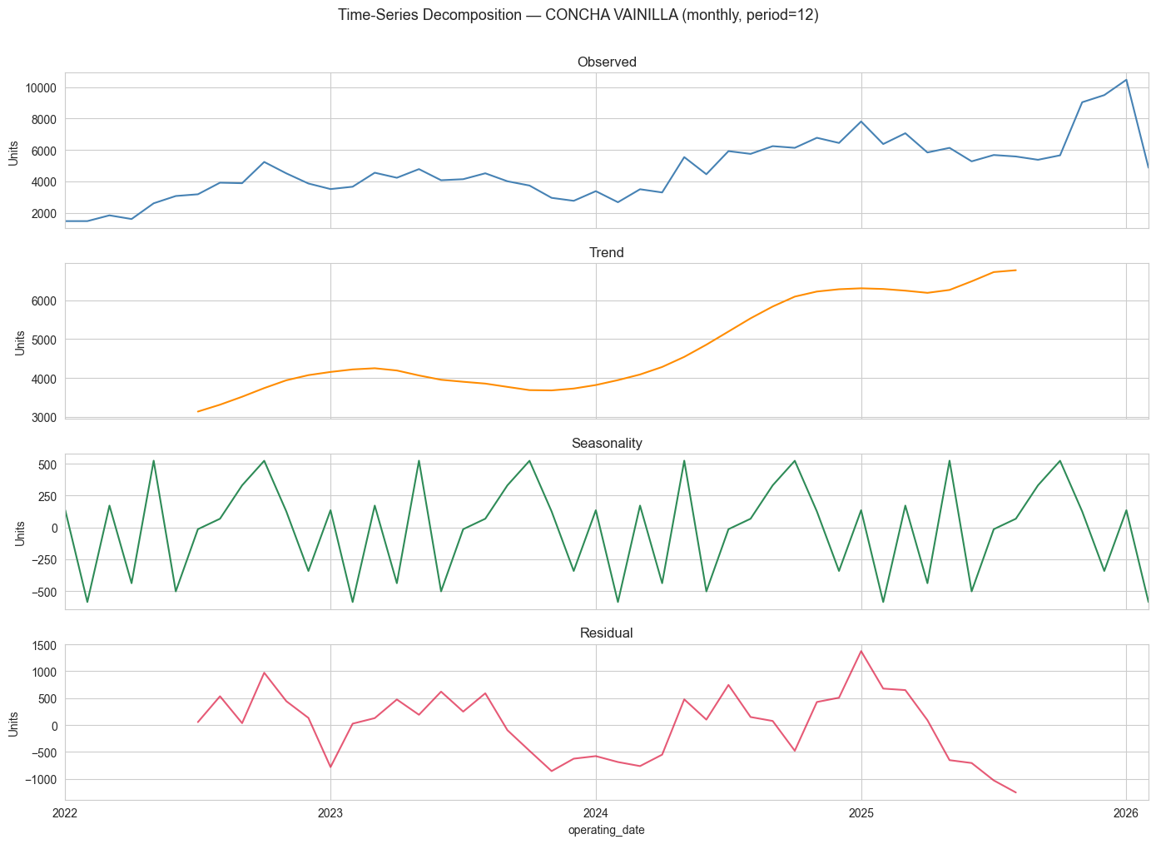
Figure 4. Monthly additive decomposition for CONCHA VAINILLA with period = 12.
Component / output | Notebook result | Interpretation
Trend slope | +93.50 units/month | Demand is increasing over the historical period.
Trend direction | UPWARD | Supports maintaining or expanding planning capacity for this product.
Peak seasonal month | 5 | May is the strongest seasonal month on average.
Trough seasonal month | 2 | February is the weakest seasonal month on average.
Daily series length | 1,474 observations | Sufficient for exploratory daily analysis.
Monthly series length | 50 observations | Enough for annual seasonality decomposition, but still limited for complex seasonal models.
Table 5. Main time-series outputs from the notebook.
The decomposition separates observed demand into trend, seasonality and residual components. The trend component rises from approximately the low 3,000 monthly-unit range toward more than 6,000 monthly units in the later period. The seasonal component shows recurring within-year deviations, while the residual component captures irregular shocks that the trend and seasonality cannot explain.
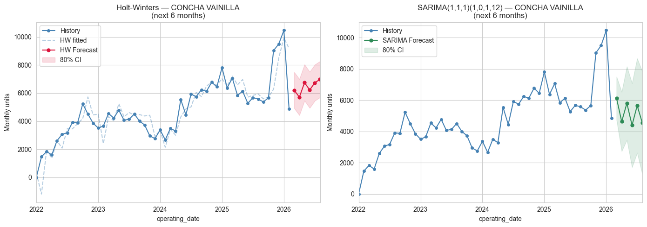
Figure 5. Six-month forecast comparison using Holt-Winters and SARIMA.
Model | Visible output | Interpretation
Holt-Winters ETS | α = 0.8801, β = 0.0000, γ = 0.0000, AIC = 723.35 | The model puts strong weight on the recent level. It is stable and useful as the primary forecast layer.
SARIMA(1,1,1)(1,0,1,12) | ar.L1 and ma.L1 significant; seasonal AR and MA not significant at 5% | Captures short-term autocorrelation, but the monthly seasonal parameters are not statistically strong in this fit.
Forecast horizon | 6 months | Appropriate for medium-term planning, but should be updated as new monthly data arrives.
Confidence interval | 80% CI shown graphically | Uncertainty widens over the horizon, so decisions should include buffers rather than point forecasts only.
Table 6. Forecast model interpretation based on the visible notebook output.
The two forecast models provide complementary views. Holt-Winters is easier to use operationally because it directly models level, trend and seasonality and remains numerically stable. SARIMA provides a formal time-series cross-check by modeling autoregressive and moving-average structure. In this run, the non-seasonal AR and MA terms are statistically significant, while the seasonal terms are not, so SARIMA should be interpreted cautiously.

8. Model Validity, Limitations and Recommendations
Overall, the analysis is valid as an exploratory modeling exercise. It answers the assignment requirements by producing a heatmap, comparing two linear regression models, analyzing trend and seasonality, and generating a six-month forecast. However, the results should be interpreted with statistical caution before being used as an automated production system.
Issue | Why it matters | Recommended action
Random train/test split in regression | Time-series observations are ordered; random splits can overstate model performance. | Use chronological validation or rolling-origin backtesting.
Rolling features dominate prediction | They improve accuracy but can create leakage if not shifted correctly. | Ensure all rolling variables are computed with past-only information, preferably shift(1).
Count-like target | Linear regression assumes continuous errors and normal residuals. | Compare against Poisson/Negative Binomial GLM, Random Forest, LightGBM or XGBoost.
Unobserved drivers | Promotions, stockouts, inventory availability and local events can explain spikes. | Add promotion flags, inventory data and branch operation context.
Category encoding | sucursal_code and season_code impose artificial ordering. | Use one-hot encoding or models that handle categorical variables safely.
Sales vs. true demand | Zero sales can mean no demand, no stock, or closure. | Integrate inventory and stockout data before deployment.
Table 7. Main limitations and recommended improvements.
- Use Model B as a short-horizon baseline, not as the final production model.
- Use Holt-Winters as a stable medium-term forecast reference, with SARIMA as a diagnostic cross-check.
- Evaluate future models using MAE/RMSE for unit error and WAPE/MAPE for comparability across products and branches.
- Do not convert the forecast directly into exact production quantities. Add safety buffers based on waste cost, stockout cost and manager judgment.
- For the next stage, build branch-product-level forecasts instead of a single all-branch forecast for the selected product.

9. Conclusion
The Stage 4.3 notebook demonstrates that Panem’s demand for CONCHA VAINILLA can be modeled in a useful way, but not with perfect precision. The correlation analysis shows that recent sales behavior is the strongest available signal. The regression analysis confirms this: adding rolling demand variables greatly improves predictive performance compared with using only calendar, branch and weather variables. At the same time, residual diagnostics show that simple linear regression does not fully match the structure of the data.
The time-series analysis adds an important business perspective. Monthly CONCHA VAINILLA demand shows an upward trend of +93.50 units per month, a seasonal peak around May and a trough around February. This pattern is actionable because production planning can anticipate higher and lower seasonal periods rather than relying only on recent intuition.
For Panem, the practical interpretation is that forecasting should support managerial decisions instead of replacing them. The forecast should be used as a quantitative baseline, then adjusted using operational knowledge, inventory constraints, upcoming events and safety buffers. The strongest next improvement is to combine this historical sales modeling with inventory and stockout information, because observed sales are not always equal to true customer demand.

